**Integrated Photonics**

**377.2.5599**

**Scientific writing task Submission: 12 January 2020**

**Lecturer: Dr. Alina Karabchevsky**

**Question 1:**

One of the basic integrated optical devices is a passive single mode waveguide device, having a higher refractive index in the guiding layer and a lower index in the substrate and superstrate. For a rib/ridge/channel waveguide and others (see Figure 1), even the simplest shape is difficult and cumbersome to deal with analytically. For this reason the numerical software plays an important role in the design of single-mode waveguides and fibers.

Consider a single mode waveguide made of silica glass and geometries as shown in Figure 1. The guiding layer of height *tg* is made of pure silica glass with refractive index n1 = 1.4457 and the substrate is doped, with a refractive index of n2 = 1.4378. The waveguide is embedded in air. The free-space wavelength is given as 1.55 μm so n1>n2>>n3. The height of the substrate is >>*tg*.

Use numerical modelling tool: COMSOL Multiphysics (one month trial version can be freely downloaded) to model the geometries shown on Figure 1.

1. Find an effective mode index of a confined guided mode and the propagation constant ** for TM and TE (are they the same?). What would be the *V* number? Relate the guided modes *m* and *V*-number.
2. Present all of the filed components of fundamental mode.
3. Characterize the modes: *TE* mode and *TM* mode.
4. Discuss the differences in field confinements between different waveguide geometries. Support your insights by the references from the literature.

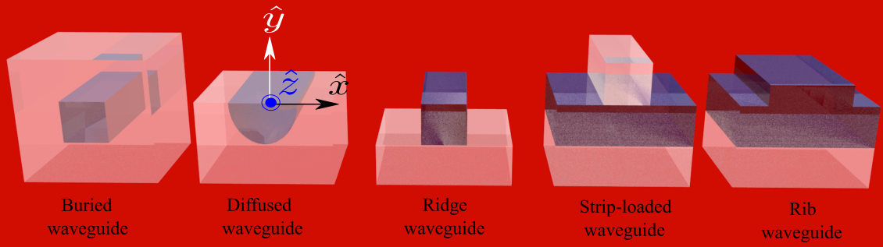

Figure Common waveguide geometries

Upload your models, extracted fields and summarizing Word document in shared drive folder.

**Question 2:**

One of the complimentary geometries to waveguides is microfibers (see Figure 2) exhibiting superior evanescent field.

Consider a single step-index fiber made of silica glass. The inner core of radius *a*=2 m, *a*=1 m, *a*=0.5 m is made of doped silica glass with refractive index of n1 = 1.4378 while the free-space wavelengths of 1.55 μm and the cladding is an air n2=1so n1>>n2. The radius of the cladding is >> *a* so that the field of confined modes is zero at the exterior boundaries.

1. Present the filed components of fundamental mode.
2. Plot the field intensity |E|2 and field cross sections.
3. What is =Pcore/Po?
4. Plot the fraction of the power in the evanescent field versus microfiber radius.

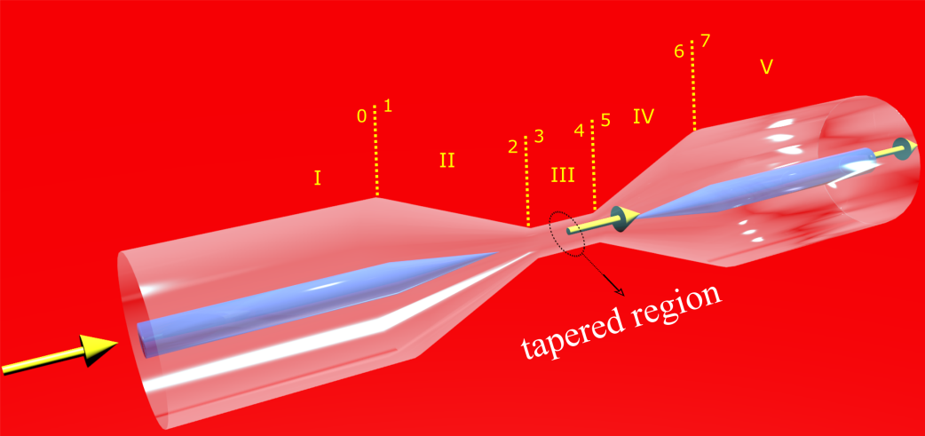

Figure 2 Microfiber

**Question 3:**

Given a planar waveguide with infinitelayers. Wave is propagating in the waveguide with wavelength of 1.5 µm while n2>>n3 as shown in Figure 3:



Figure 3 – planar waveguide with infinite layer illuminated by λ=1.5 µm

1. Find a refractive index n3 that allows for propagation of three TE modes in the waveguide. Find the propagation constants (β) in the z direction for these modes.
2. Give an explicit expression for Ey(x) at each layer for the modes you found in (a) (including the amplitude and the propagation constant in the z direction).
3. Draw Ey(x) for each mode.
4. By using n3 from section a, find the propagation constants (β) in the z direction for possible TM modes Hy(x). Did you obtain the same propagation constants for the two polarizations? If not explain qualitatively.
5. Give an explicit expression for Hy(x) at each layer for the modes you found (including the amplitude and the propagation constant in the z direction).
6. Draw Hy(x) for each mode.
7. Draw Ey(x) and Hy(x) for the different modes on the same graph.
8. Draw Ey(x,z) (in the size of two wavelengths without time dependence) from a chosen mode. (3D graph)
9. In this section, describe shortly the steps to express the function of Hy(x) for each layer for TM polarization (similar to the expression that we did in the lecture for TE polarization). The final formula is written at the end of this section. Follow the missing development steps according to the guidance in Appendix 1.

**Appendix 1:**

Start from Maxwell equation:

1. Assume: 1. In the waveguide, a harmonic wave is propagating in the z direction.

2. The waveguide is infinite in the y direction and the magnetic field doesn't change in this direction .

**Show that** the propagating electric field can be written as:

1. Use the fact that this are TM modes**(?)**

**Show that:**

1. **Show that** the general solution of the equations in each region is:
2. Write equations for q, p and h.
3. Use the boundary conditions for the continuity of the magnetic field for x=0 and x=-tg .

**Show that:**

1. Use the boundary conditions for the continuity of the electric field for x=0 and x=-tg while

**Show that:**

1. Use equations 3 and 4 and **show that:**

Where

1. Use equations 1 and 2 and **show that:**

**Summary:**

The final formula to the magnetic field for TM modes in the waveguide.

Where (from developing the total power and normalizing. Don't need to calculate.)

GOOD LUCK!