Contact details of the presenting /corresponding author:

Second Name: Karabchevsky
First Name: Alina
Institution: Ben-Gurion University of the Negev
Street Address: Reger
City: Beer-Sheva
Zip: ​8410501
Country: Israel
Email Address: alinak@bgu.ac.il
Telephone Number: 972-53-2232299

Copyright Statement:
With the submission of this abstract, the authors agree that the abstract may be used by the organizers to prepare the Book of Abstracts for the conference. The author herewith declares on behalf of all co-authors that the submitted abstract is not subject to any copyright issues.

Please scroll down for a sample abstract on the following page.
Note: The length of the abstract should not exceed one page!

1. Yang, Y. et al. Femtosecond optical polarization switching using a cadmium oxide-based perfect absorber. Nature Photonics 11, 390 (2017).
2. Karabchevsky, A., Katiyi, A., Abdul Khudus, M.I.M. and Kavokin, A.V., Tuning the near-infrared absorption of aromatic amines with photonic microfibers sculptured gold nanoparticles, ACS Photonics, 5 2200-2207, (2018).
3. Karabchevsky, A., Mosayyebi, A. & Kavokin, A. V. Tuning the chemiluminescence of a luminol flow using plasmonic nanoparticles. Light: Science & Applications 5, (2016).

All-optical switch with hybrid plasmonic molecular systems: sensing or switching?
A. Karabchevsky^{1,2}, A. Hazan¹
¹Electrooptics and Photonics Engineering Department, Beer-Sheva 8410501, Israel
²Ilse Katz Institute for Nanoscale Science & Technology, Center for Quantum Information Science and Technology, Ben-Gurion University of the Negev, Beer-Sheva 8410501, Israel
alinak@bgu.ac.il URL: http://www.alinakarabchevsky.com/

Key words: optical switch, plasmonics, nanoparticles, molecular overtones, dielectric waveguide.

Optical switches selectively switch optical signal from switched-on to switched-off. Compared to the traditional electronic switches, optical switches are not limited by thermal effects or electromagnetic interferences. Here we show metamaterials-based probing of weak quantum absorber in coupled three-resonator system which reveals the signature of optical switching. The polarization dependent probing of molecular overtones excited in a hybrid system tune the state: when the system is illuminated by transverse magnetic polarized light the switch is on while for the transverse electric polarized light the switch is off.

We explored the system in which three coupled oscillators are excited. Despite the relatively low oscillator strength of the corresponding forbidden dipole transition in harmonic oscillator approximation we constructed an optical switching system based on polarization depending properties of the plasmon-to-overtone coupled modes. This all-optical switching manifold is realized by excited localized surface plasmons (LSP) which couple to the molecular vibrations overtones. LSP in the system are excited by the extended surface plasmons (ESP) which in turn are excited by the guided modes of a waveguide structure.

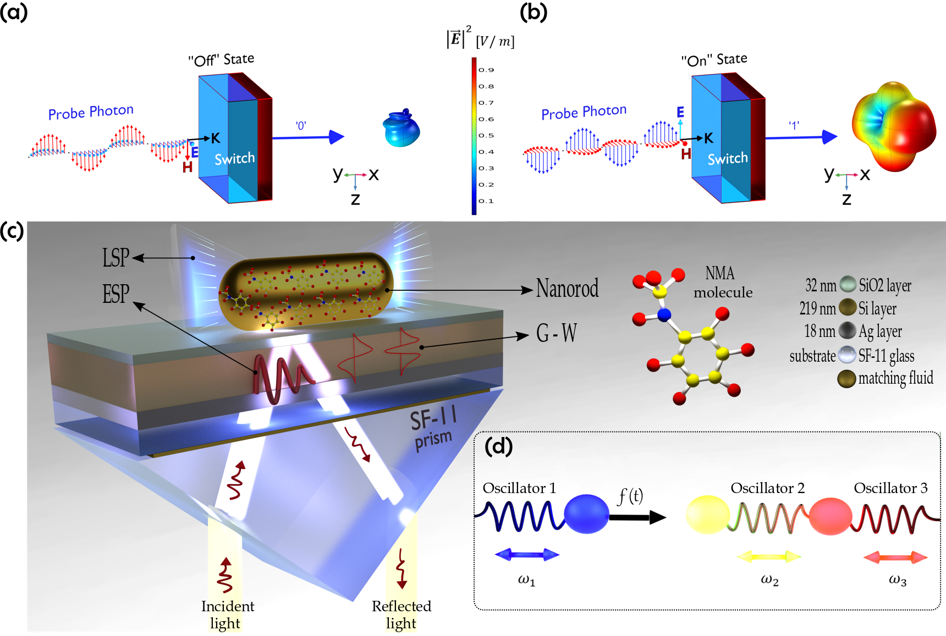

Figure 1. Schematic illustration of polarized beam incident the switch. (a) The state ‘off’ is activated when the TE polarized beam hits the switch, (b) the state ‘on’ is activated when the TM polarized light hits the switch. (c) Artistic representation of experimental setup. (d) Mechanism of coupled oscillators.

